Submission Report

1. My decisions

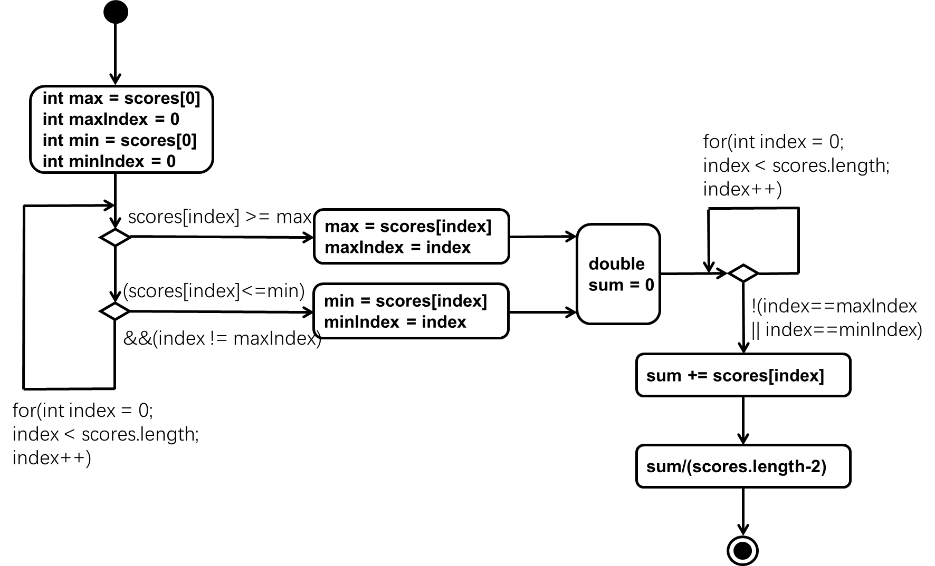I chose three digits as competitor number, and age and country as extra attributes. I used four kinds of level which are common, uncommon, rare and legendary. There are five scores in each competitor and the value between 0 and 5 included.

graph1. Activity diagram of overall score calculation

2. Status report

This application meets the specification fully.

|  |  |
| --- | --- |
| Problem | Effect |
| A long name, a long country name, the uncommon level | A single \t cannot hold anymore, this will break the structure of table |
| The number of scores, the value of scores | Assume that won’t happened |
| The primary key isn’t a three digitals number | This is unlikely to occur |

table1. Known limitations of application

|  |  |
| --- | --- |
| Test | Tested |
| There are too many comma | ,,,,,,,,,,,,,,,,,,,,,,,,,,,,,,,, |
| Empty line |  |
| Some information lack or forget comma | 101, Jane Macdonald Uncommon, United Kindom, 23, 3,1,3,2,4 |
| Useless information | fdgfsfgsfsg |
| Input wrong file | System.xml |
| Duplicated primary key | 100, Keith John Talbot, Common, UK, 31, 5,4,5,4,3  100, Sarah Green, common, Iceland, 20, 4,0,4,2,3 |
| Can’t find the file | asdfsdf.txt |
| Can’t write to file | The file is read only |
| There is no space between first name and last name | 106, KarenHarding, Rare, Austrilia, 25, 5,5,5,4,1 |
| Two competitor have same highest overall score | 105, Geralt Of Rivia, Rare, Oxenfurt, 105, 5,5,5,5,5  109, Darth Maul, Legendary, Dathomir, 52, 5,5,5,5,5 |

table2. Known bugs and tested

3. Diagrams

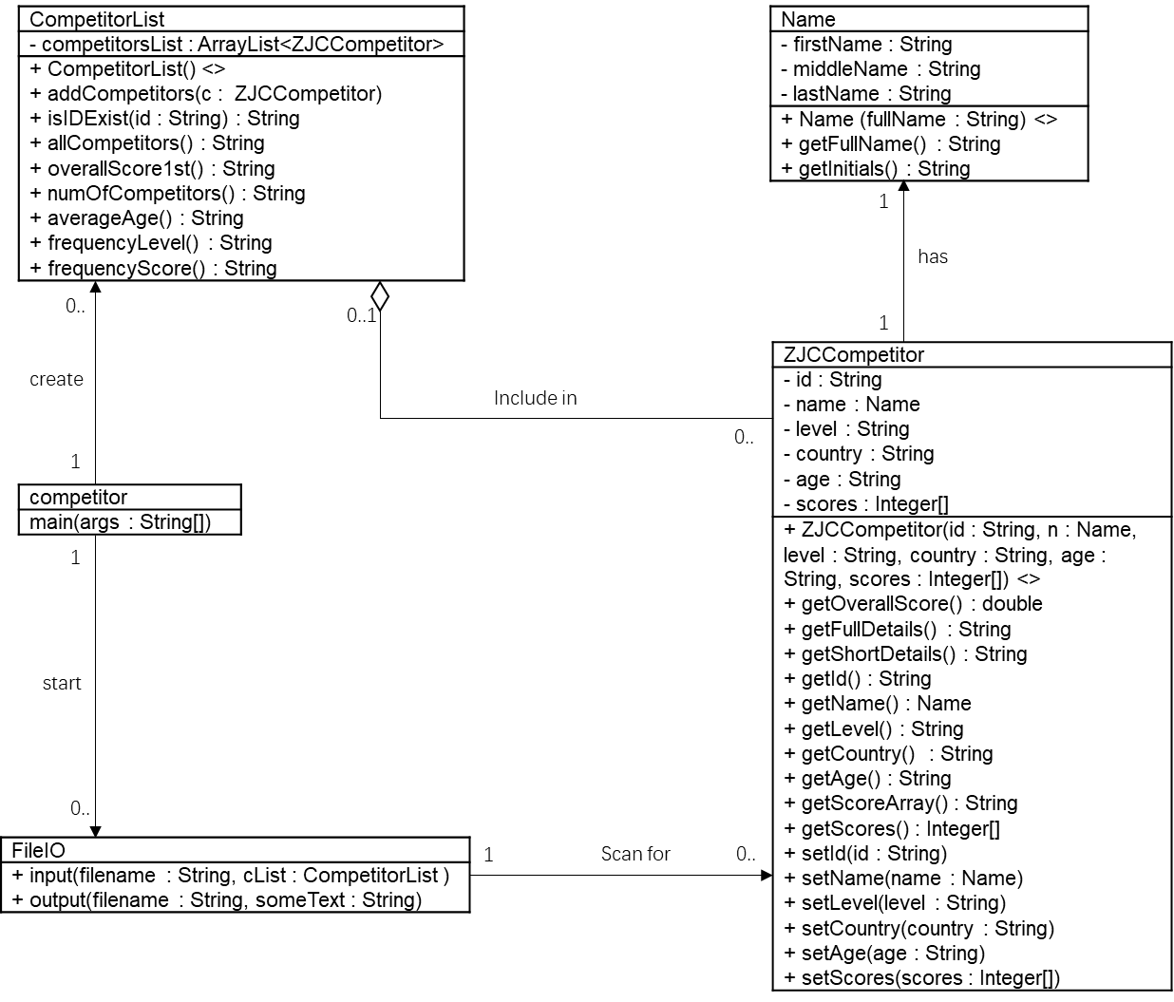

picture2. Class diagram

picture3. sequence diagram of input method 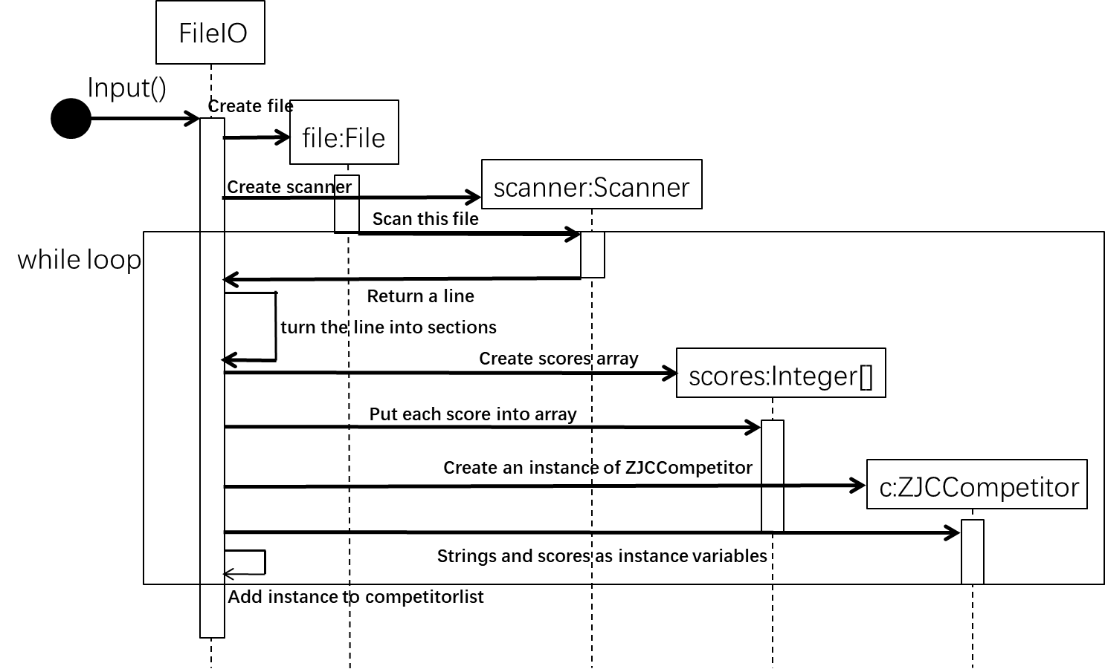

4. JavaDoc